Storage Devices

What is a storage device?
Storage devices are the computer hardware used to remember/store data.
There are many types of storage devices, each with their own benefits and drawbacks.
Below are explanations about different storage devices.:
- Hard Disk Drive (HDD)
- Solid State Drive
- Random Access Memory (RAM)
- CD, DVD and Blu-Ray Discs
- DVD-RAM
- ROM
- USB Flash Memory

Hard Disk Drive (HDD)

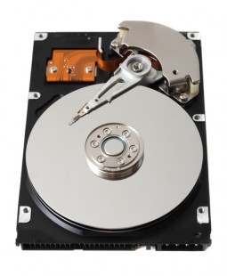What is a hard disk drive?
Hard disk drives are non-volatile magnetic storage devices capable of remembering vast amounts of data.
An electromagnet in the read/write head charges the disk’s surface with either a positive or negative charge, this is how binary 1 or 0 is represented.
The read/write head is then capable of detecting the magnetic charges left on the disk’s surface, this is how data is read.
The disk surface is divided into concentric circles (tracks) and sectors (wedges). Dividing the surface in this way provides physical addresses to remember where data is saved.
A circuit board carefully co-ordinates the rotating disk and swinging actuator arm to allow the read/write head to access any location very quickly.
Typical HDD capacities are measured in Terabytes (TB).
They can be installed inside a computer or purchased in a portable (external) format.

Typical applications for hard disk drives
- Desktop computers
- Laptop computers
- TV and satellite recorders
- Servers and mainframes
- Portable (external) drives are sometimes used to backup home computers or transfer large files

Benefits of hard disk drives
- Capable of holding vast amounts of data at affordable prices
- Fast read and write speeds
- Reliable technology
- Relatively small in size

Drawbacks of hard disk drives
- Due to the nature of its moving parts, they will eventually wear and break
- Although very fast, waiting for the moving parts means it will never perform as fast as solid state drives
- More fragile and less robust than a solid state drive
- Higher power consumption than a SSD
- Some noise is created by the moving parts

Solid State Drive (SSD)
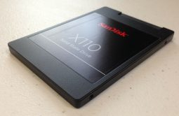

What is a solid state drive?
Solid state drives are non-volatile storage devices capable of holding large amounts of data.
They use NAND flash memories (millions of transistors wired in a series on a circuit board), giving them the advantage of having no mechanical moving parts and therefore immediate access to the data.
Solid state drives perform faster then traditional hard disk drives, however they are significantly more expensive.
This expense means that typical capacities are usually measured in Gigabytes (GB).
They can be installed inside a computer or purchased in a portable (external) format.
Until we reach a point were large capacity SSDs are affordable, a compromise is to run two disk drives inside a computer. An SSD as the primary drive for your important programs and operating system, and a traditional HDD to store music, documents and pictures (which don’t need the faster access times).
The lack of moving parts in an SSD makes it very robust and reliable, ideal for a portable device.

Typical applications for solid state drives
- Smartphones
- Tablet computers
- High-end laptops
- Two drive desktop solutions
- Portable drives are sometimes used in HD video cameras

Benefits of solid state drives
- Extremely fast read/write speeds
- Small in physical size and very light, ideal for portable devices
- No moving parts to wear, fail or get damaged – ideal for making portable computers and devices more reliable and durable
- Uses less power than a HDD, increasing battery life time
- Very quiet
- Generates less heat

Drawbacks of solid state drives
- Expensive to buy (per GB)
- Limited in capacity due to the expense
- Limited amount of writes

Random Access Memory (RAM)

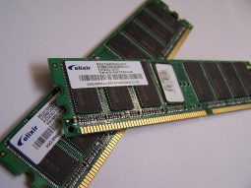What is RAM?
RAM is a computer’s primary memory. It is a very fast solid state storage medium that is directly accessible by the CPU.
Any open programs or files on a computer are temporarily stored in RAM whilst being used.
Being volatile, any data stored in RAM will be lost when power is removed. This makes RAM totally unsuitable for the long term permanent storage of data – that is the role of a HDD or SSD instead.
Data is copied from secondary storage (HDD, SSD) to RAM as and when it is needed. This is because using a HDD as the primary memory would cause a computer to perform much slower (a HDD or SSD is not directly accessible to the CPU, and isn’t as fast as RAM).
RAM is a relatively expensive storage device and typical capacities are measured in Gigabytes (GB).
Computers operating with a capacity of RAM above the recommended minimum will benefit from better performance and multitasking.
There are two types of RAM (SRAM and DRAM), each with their own advantages and disadvantages.

Typical applications of RAM
- The fast and directly accessible temporary (working) memory needed by a computer

Benefits of RAM
- Directly accessible to the CPU, making processing data faster
- Fast solid state storage, making processing data faster

Drawbacks of RAM
- Relatively expensive memory
- Volatile – any data stored in RAM is lost when power is removed

Static RAM (SRAM)
Data on SRAM does not require refreshing.
However, the technology is bulkier meaning less memory per chip.
- More expensive than DRAM
- Much faster than DRAM
- Consumes less power
- Commonly used in cache memory

Dynamic RAM (DRAM)
The most common type of RAM in use.
The data needs to be continually refreshed otherwise it fades away.
Continually refreshing the data takes time and reduces performance speeds.
- Cheaper than SRAM
- Commonly used in main memory

CD, DVD and Blu-Ray Discs

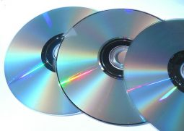What are optical storage discs?
CD, DVD and Blu-Ray drives are optical storage devices.
Binary data is stored as changes to the texture of the disc’s surface, sometimes thought of as microscopic pits and bumps.
These ‘bumps’ are located on a continuous spiral track, starting at the centre of the disc.
Whilst the disc is rotating at a constant speed, a laser is pointed at the spiral track of ‘bumps’.
The laser will reflect/bounce off the disc surface in different directions depending upon whether a 1 or 0 has been read.

Disc capacities
In the pursuit of larger optical storage capacities, DVDs were created, followed by Blu-Ray.
CD | DVD | Blu-Ray
700 MB | 4.7 GB | 25 GB – 128 GB

Typical applications for optical media
- CD – Audio and small amounts of data
- DVD – Standard definition movies and data
- Blu-Ray – HD video and large amounts of data

DVD
Despite being the same physical size, a DVD can hold more data than a CD.
To achieve this, a more tightly packed spiral track is used to store the data on the disc.
To accurately access the smaller ‘bumps’, a finer red laser is used in a DVD drive than that found in a standard CD drive.
To increase capacity further, DVDs are also capable of dual layering.

Blu-Ray
Blu-Ray technology squashes even more data into the same size disc as a CD or DVD.
The spiral data tracks on a Blu-Ray disc are so small a special blue (violet) laser has to be used to read the ‘bumps’.
Like a DVD, Blu-Ray discs are capable of storing data on multiple layers.

Recordable Optical Media

CD-ROM, DVD-ROM, Blu-Ray-ROM
Read only – the data is permanently written to the disc at the point of manufacture.

CD-R, DVD-R, BD-R
Recordable – blank discs that can be burnt (written to) once.

CD-RW, DVD-RW, BD-RE
Re-writable – blank discs that can be burnt (written to) over and over again (can be erased and reused many times).

DVD-RAM
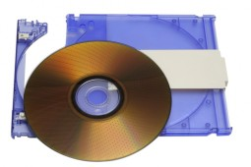

What is DVD-RAM?
DVD-RAM is an optical media storage device.
It differs from a traditional DVD in that data is stored in concentric tracks (like a HDD) which allows read and write operations to be carried out at the same time.
This means, for example, that when used in a personal video recorder you can record one television programme whilst watching a recording of another. This allows handy features such as ‘time slip’ to be possible.
When used within a CCTV system you could review footage whilst still recording your cameras.
The capacity of DVD-RAM is 4.7 GB, or 9.4 GB for double-sided discs.

Typical applications for DVD-RAM
- Personal and digital video recorders
- High-end CCTV

Benefits of DVD-RAM
- Read and write at the same time
- Can be rewritten to many more times than a traditional DVD-RW
- Has write-protect tabs to prevent accidental deletion when used in an optional cartridge
- Data is retained for an estimated 30 years. This long life is great for archiving data
- Reliable writing of discs because the verification done by the hardware, not by software

Drawbacks of DVD-RAM
- Disc speeds higher than 5x are less common
- Less compatibility than DVD-RW

ROM

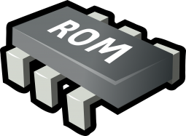What is ROM?
ROM is a non-volatile memory chip whose contents cannot be altered.
It is often used to store the start up routines in a computer (e.g. the BIOS).

Typical applications for ROM
- Storing the computer’s start up routine

USB Flash Memory

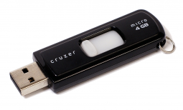What is USB Flash Memory?
Flash are non-volatile solid state storage devices which use NAND flash memories to store data (millions of transistors).
USB refers to the USB connection that allows users to plug the device into the USB port of a computer.
Other types of flash storage include the memory cards used in digital cameras.
Flash memory comes in a variety of capacities to suit most budgets and requirements.

Typical applications for flash memory
- USB memory sticks – saving and transferring documents etc
- Memory cards in digital cameras

Benefits of flash memory
- Portable, small and lightweight
- Durability, flash has no moving parts to damage
- Range of capacities available
- Fast speeds, with no moving parts of boot up time

Drawbacks of flash memory
- Limited (but huge) number of write cycles possible
- Really high capacities are uncommon
- In relative terms, an expensive storage option compared to a HDD
k

